WEBPAGE KIT:
SECTION: What is Atrial Fibrillation
Who is affected by Atrial Fibrillation:
Atrial Fibrillation (also known as Afib or AF) is the most commonly diagnosed abnormal heart rhythm (arrhythmia) in the U.S.¹
- 8 million people in the U.S. have Afib¹
- 1 in 4 adults will develop Afib in their lifetime²
- 37 million people around the world have Afib³
What is Atrial Fibrillation:
Insert animation video…PM-GL-1424C-0625-G
Atrial Fibrillation is common
Atrial fibrillation is the most commonly diagnosed abnormal heart arrhythmia. Afib gets worse over time. It is best to have atrial fibrillation treated before it progresses and causes other health problems.⁴
Consider inserting patient video here…
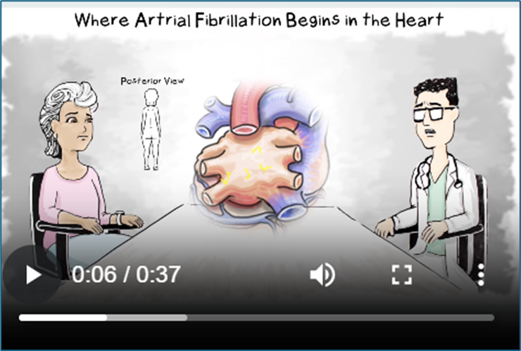

There are 3 areas in the heart where Afib normally starts. The trigger points are:
- The base of the pulmonary veins (PV)
- The posterior (back) wall of the left atrium
- The left atrial appendage (LAA)

The stages of Afib
As Afib progresses, there are different stages and symptoms someone may experience based on the duration.
Paroxysmal - Stops spontaneously or with intervention within 7 days of onset.
Persistent – Lasts beyond 7 days but is less than 12 months duration.
Long-standing Persistent – Lasts beyond 12 months.
Long-standing persistent is also referred to advanced, chronic, and permanent Afib. If you have been in Afib for longer than 12 months, take a quick screener to see if you qualify for Hybrid AFTM Therapy.

Consider inserting video here…
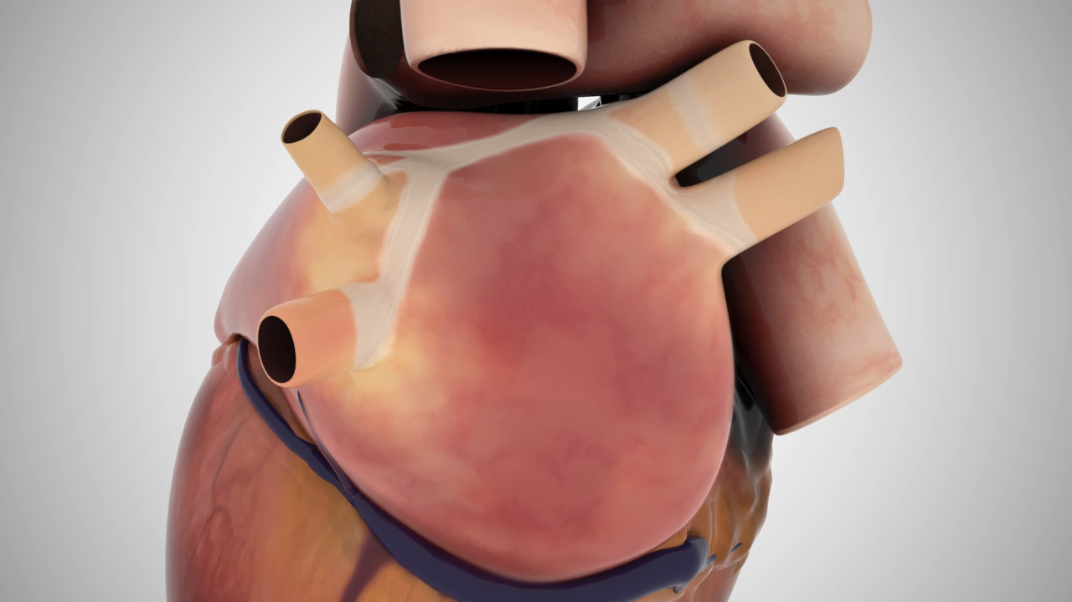
Progression of Afib leads to:
- Scarring – Afib can lead to scarring of the atrial tissue
- Stretching – Eventually the heart tissue becomes stretched. As the walls of the heart are stretched, the heart muscle becomes weaker
- Stiffening – The heart muscle gets stiffer, so that it is harder for the heart to pump

Afib is a progressive disease:
Consider inserting patient video here…
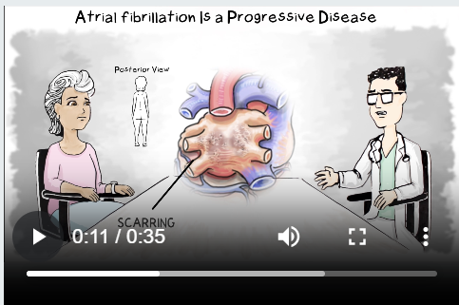

Symptoms and Causes of Afib⁵

Afib is considered a part of aging. In fact, 1 in 4 over the age of 40 will develop Afib in their lifetime.² Other risk factors include^{6&7}:
- Family history
- Heart attack, heart failure, or heart surgery
- High blood pressure
- Obesity
- Sleep apnea
- Caffeine, nicotine or illegal drug use
- Drinking too much alcohol
- Changes in the level of body minerals
- Other long-term health conditions, such as diabetes and thyroid disease

Early signs of Afib can be mild, with symptoms including:
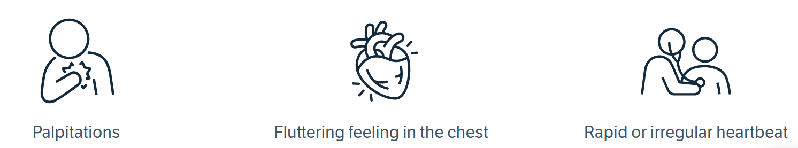

Symptoms of persistent and long-standing persistent, can be different and more severe.
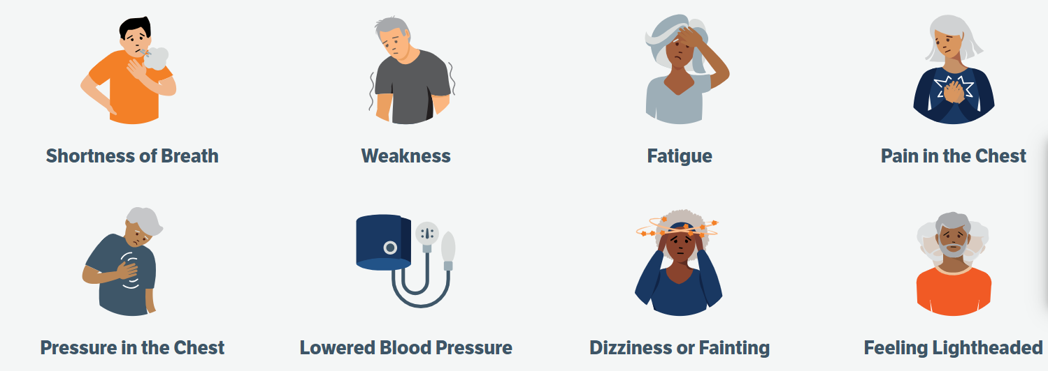

Many other factors that can lead to Afib, listed below,^{6,7} are within your control. Talk to your health care provider about how to lead a healthy lifestyle.
- Smoking—The risk seems to increase for long-term smokers. But the risk lowers if you quit.
- Stress—Emotional stress, including panic disorders, can also put someone at higher risk of Afib
- Alcohol—Alcohol consumption, and especially binge drinking, raises a person’s risk
- Caffeine—Caffeine increases the heart rate, which can trigger atrial fibrillation⁸

Section: Why Treatment is Important:
WHY treating your Atrial Fibrillation is so important:
Atrial Fibrillation (Afib) can negatively affect how a person feels. People with Afib often need to take medications to prevent clots, slow the heart rate and/or the heart rhythm. Afib can also impact an individual's quality of life due to symptoms of Afib, side effects of medication and frequent clinic and doctor visits. The symptoms of Afib can cause a decrease in quality of life. If left untreated, Afib can scar, stretch, and stiffen the heart muscle.

Atrial fibrillation also puts people at higher risk for other health conditions, including:
- 5x increase in stroke risk⁹
- 5x increase in heart failure development¹⁰
- 3x increase in Dementia¹¹
- More cardiac complications
- Decrease in general and mental health
- Other health problems
How does Afib lead to stroke?
Data show that 15-20% of strokes are related to Afib.⁷
Afib causes the atria to beat too fast. The atria cannot contract as they should. As a result, blood pools in the atria. When blood pools, it can clot. If a blood clot travels to the brain, it can cause a stroke.
What is the connection between Afib and Heart Failure?
Heart failure is a condition in which your heart can't pump out enough blood to meet your body's needs. The stretching, stiffening, and uncoordinated pumping of the heart can lead to heart failure. Heart failure causes changes to heart tissue in the atrium, making Afib much more likely.¹² Symptoms get worse as heart failure progresses. Currently, heart failure has no cure. The combination of Afib and heart failure can increase the risk of stroke, worsen heart failure, and further reduce ability to go about daily activities. However, treatments can help people live longer and be more active.
Symptoms of heart failure include:
- Fatigue
- Shortness of breath or trouble breathing
- Swelling in the ankles, feet, legs, or abdomen

Section: Treatment Options

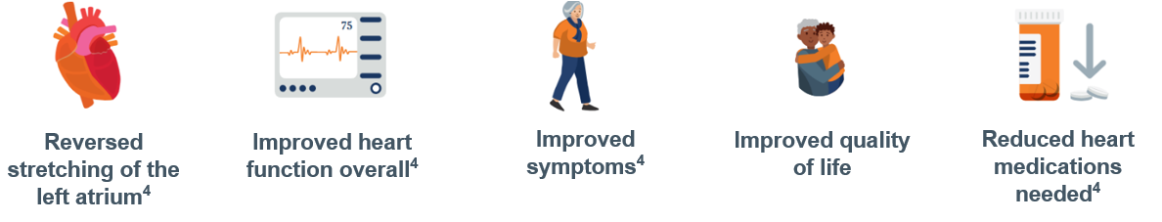
Treatment options:
Treatments vary, depending on the stage of Afib. Because the undertreated Afib can progress to more advanced stages, it is very important to talk with your healthcare provider about proper treatment.

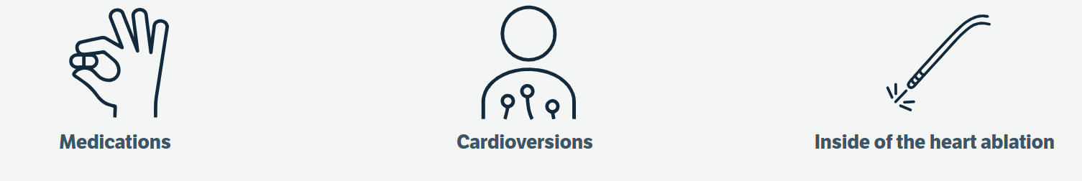

Medications can help a person in different ways:
- Medications can treat blood pressure, diabetes, or an overactive thyroid
- Blood thinners can reduce the risk of stroke
- Rate control medications slow the heart rate
- Rhythm control medications can help control the rhythm of the heart
Cardioversions:
- Cardioversion is done at the hospital or clinic and delivers a controlled electric shock to the outside of the chest to restore a normal heart rhythm

Lifestyle changes:
- Make exercise and healthy food choices as part of your daily life.
- If needed, get a sleep study to determine if you have sleep apnea and get CPAP therapy as needed.
If your symptoms continue and are not controlled by medications, your physician may consider a catheter ablation.
- An ablation is the formation of a lesion on the inside or the outside of the heart. A lesion forms a barrier that can eliminate the areas for Afib. Ideally, a lesion would go all the way through the heart tissue. The more a lesion goes through the heart tissue, the more effective the barrier. If the ablation is successful, the areas of Afib are eliminated. Over the months following an ablation, the heart’s rhythm and function should improve
- The goal of the ablation is to stop atrial fibrillation or to make the episodes of Afib shorter and less frequent
- In the past, people with advanced atrial fibrillation had fewer treatment options to stop their Afib
- Now Hybrid AF Therapy is an option
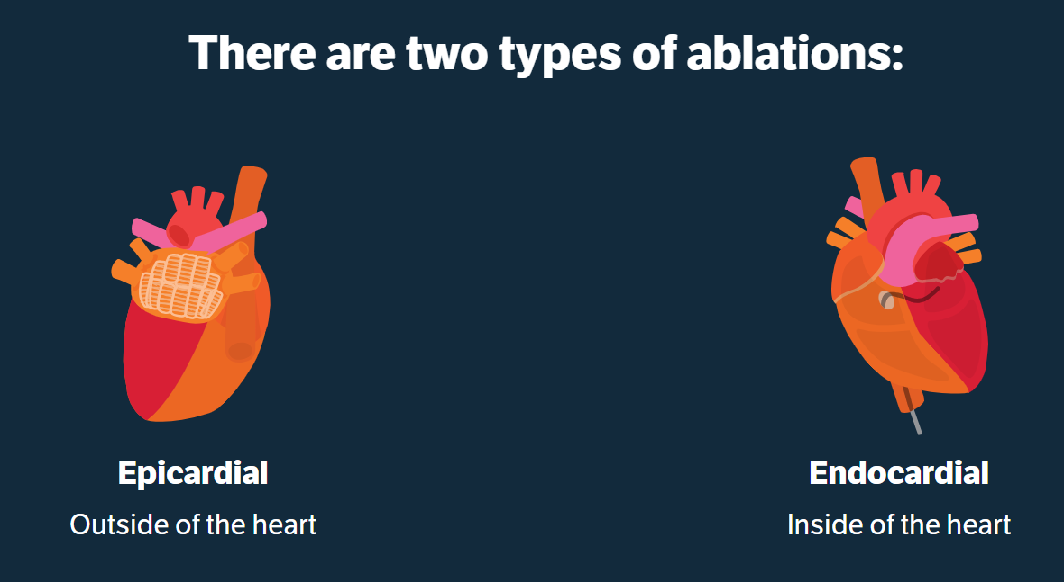

Consider inserting video here…
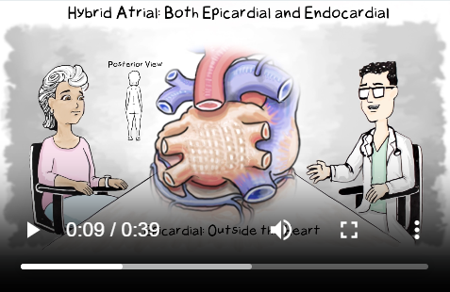

Hybrid AFTM Therapy treatment for advanced Atrial Fibrillation:
Hybrid AF Therapy combines both types of ablations. It creates lesions inside and outside the heart and is used to treat advanced Afib.
Hybrid AF Therapy is a safe and effective option to treat the over 3.5 million⁸ people with advanced Afib. If your Afib has lasted for more than a year, there's hope for effective treatment, even if previous treatments have failed.
If you have advanced Afib, your doctor may recommend Hybrid AF Therapy.

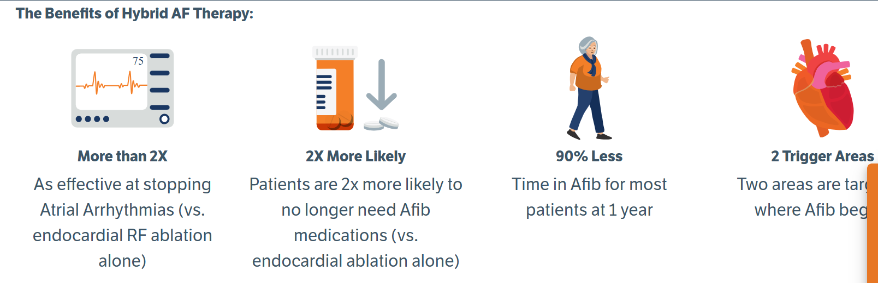

What to expect from the Hybrid AF Therapy
Step 1 of the procedure – Epicardial treatment on the outside of the heart
- The doctor makes a small 2-3 cm incision under the breastbone
- Once the doctor has access to the heart, lesions are created across the posterior (back) wall of the heart
- These epicardial lesions overlap to create a barrier to the erratic electrical signals that cause Afib

Consider inserting patient video here…
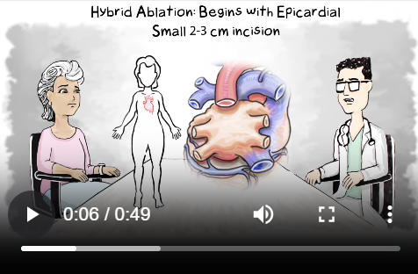

Step 2 of the procedure – Endocardial lesions on the inside of the heart
- Endocardial (inside of the heart) lesions target areas of the heart that are difficult to reach from the outside
- A second doctor makes a small incision in the femoral vein in the upper thigh. This allows access to your heart through the vein
- The doctor looks at an electrical “map” of your heart to address any remaining abnormal electrical signals that may not have been treated in the first procedure
- The doctor then creates lesions at the pulmonary veins and at any areas that still have abnormal electrical activity

Consider inserting patient video here…
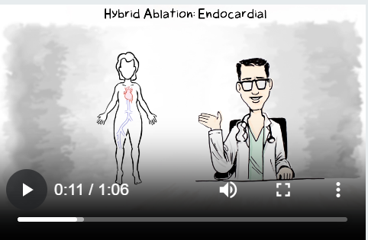
Your hospital stay will typically be 2-3 days, your doctor will:
- Prescribe medication to prevent inflammation soon after the procedure
- Tell you when you can resume taking needed heart medications
- Tell you if you may be able to stop taking certain heart medications
- Tell you when you can return to daily activities

The goal of ablation treatment for atrial fibrillation is to stop the irregular heart rhythm or reduce Afib episodes, so that they are shorter and less frequent. This helps the heart return to a more normal size, pimp more efficiently, and improve its overall function.⁴

Is Hybrid AF Therapy for you?
- It may be, but only a healthcare provider can determine the best treatment for you
- Talk to your doctor about how to find the right treatment for your stage of atrial fibrillation

Hear from a patient who underwent the Hybrid AF Therapy…
Consider inserting patient video here…
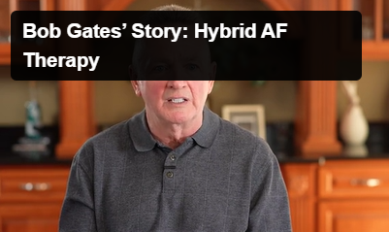

Insert hospital video from the physician who performs the Hybrid AF Therapy…
- Hospital created content

References:
  - Colilla, S. et al. (2013). Estimates of current and future incidence and prevalence of atrial fibrillation in the U.S. adult population. American journal of cardiology, 112(8), 1142-1147.
  - Lloyd-Jones DM et al. (2004). Lifetime risk for development of atrial fibrillation. Circulation, 110, 1042-1046.
  - Lippi G et al. (2021). Global epidemiology of atrial fibrillation: An increasing epidemic and public health challenge
  - Benussi, S., & de Maat, G.E. (2018). Atrial remodelling and function: implications for atrial fibrillation surgery. European journal of cardio-thoracic surgery, 53(i1):i2–i8, https://doi.org/10.1093/ejcts/ezx340
  - National Institutes of Health. Atrial Fibrillation. Accessed July 2024. Retrieved from https://www.nhlbi.nih.gov/health-topics/atrial-fibrillation.
  - Benjamin EJ, Muntner P, Alonso A, et al. Heart disease and stroke statistics—2019 update: a report from the American Heart Association. Circulation. 2019;139(10):e56–e528.
  - Benjamin E, Levy D, Vaziri SM. Independent risk facors for atrial fibrillation in a population based cohort. JAMA. 1994;271(11):840–844.
  - (Rahman, F., et al. (2014). Global epidemiology of atrial fibrillation. Nature reviews cardiology, 11, 639-654. https://doi.org/10.1038/nrcardio.2014.118
  - . Odutayo, A. et al. (2016). Atrial fibrillation and risks of cardiovascular disease, renal disease, and death: systematic review and meta-analysis. BMJ, 354, i4482.
  - 7. Boriani, G., & Proietti, M. (2017). Atrial fibrillation prevention: an appraisal of current evidence. Heart, 104(11):882-7
  - Bunch TJ et al. Arrhythmia & Electrophysiology Review 2019;8(1):8–12
  - Bergau, L et al. Atrial Fibrillation and Heart Failure. Journal of Clinical Medicine. 2022 Apr 29;11(9):2510. doi: 10.3390/jcm11092510

